EM3490/3490B
High Voltage Insulation Resistance Tester

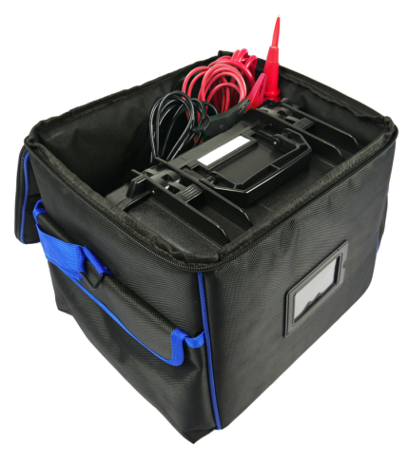
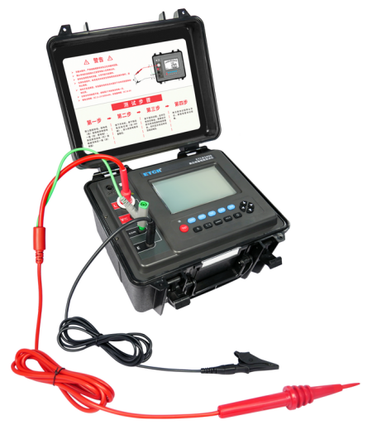
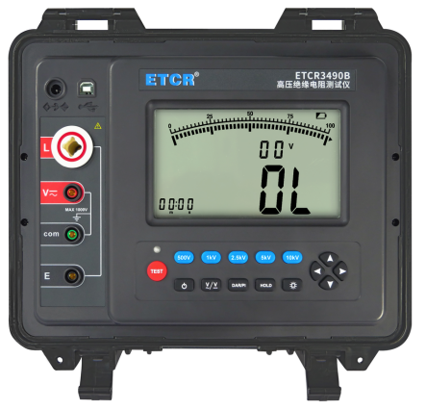

Product Function
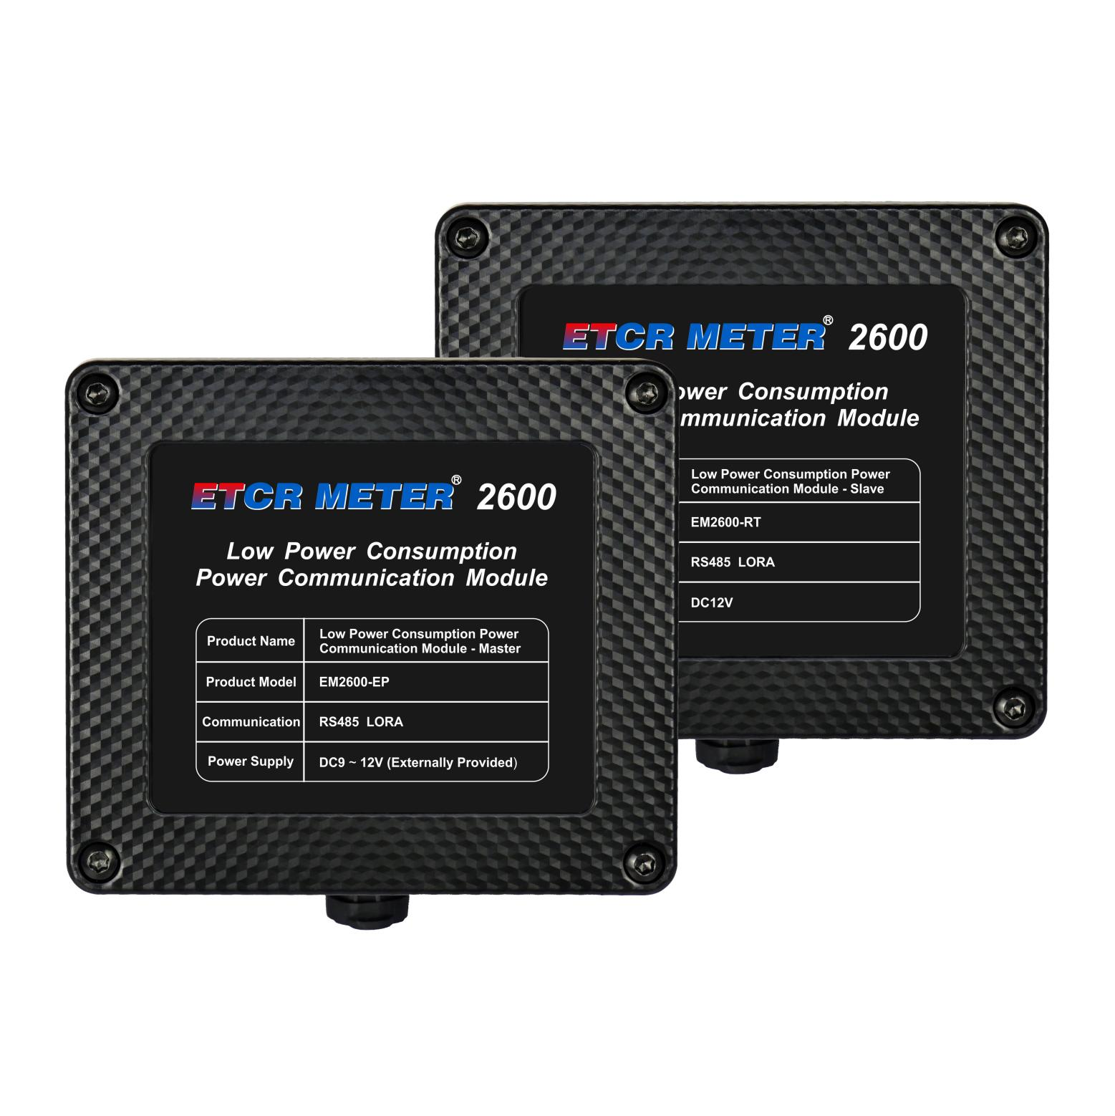
- Suitable for measuring the resistance values of various insulating materials and the insulation resistance of transformers, motors and electrical equipment, etc.
- Insulation Resistance Test (IR); Polarization Index Test (PI); Dielectric Absorption Ratio Test (DAR); AC / DC Voltage Test (V).

- The insulation resistance value, test time, and output voltage test data can displays on the same screen. It is very convenient for test operation and historical record query.
- It has unique strong anti-interference technology, with stable testing capability in scenarios with large distributed capacitance (such as long cables) and strong electromagnetic interference environments (such as substations).
- Complete measurement indicators: Insulation Resistance (IR), Polarization Index (PI), Dielectric Absorption Ratio (DAR), AC / DC Voltage (V).
- It is automatic discharge function can automatically and quickly releases the charging charge of the measured object after testing, without an additional discharge circuit.
- The test records can be directly browsed and analyzed on the large-capacity test record memory. It can automatically store 600 groups of real-time test data with test timing.
- The test records can be uploaded to computers for data storage, statistics and analysis by USB communication and upload function.
- The bluetooth communication function can upload the test results to mobile phones.

Product Features


Technical Specification
Model | EM3490 | EM3490B
Power Supply | DC11.1V, 2600mAh rechargeable lithium battery
Rated Voltage Range | 250V,500V,1000V,2500V,5000V | 500V,1000V,2500V,5000V,10000V
Output Voltage Accuracy | + 4% ± 10V | + 4% ± 10V
Insulation Resistance Measuring Range | 0.1MΩ ~ 5.00TΩ | 0.2MΩ ~ 10.00TΩ
Short-circuit Current | 5mA MAX | 5mA MAX
Voltage Measurement | Range: AC 750V/DC 1000V, Accuracy: ± 1.5%rdg ± 3dgt
Polarization Index (PI) | Yes
Dielectric Absorption Ratio (DAR) | Yes
Real-time Voltage Indication | Real-time monitoring of test terminal voltage; testing is prohibited when the voltage exceeds 36V in non-test state to protect the instrument and operators.
Measuring Time | Single test time is 10min; users can stop manually during the test or stop automatically after 10min, and the measurement data is displayed on the screen.
Storage Function | Automatically store 600 groups of test data; stored test records can be displayed and played back on the meter.
USB Communication | Yes; test records can be transferred to PC via USB cable.
Bluetooth Communication | Yes
Battery Power Indication | Equipped with battery power indication; when battery voltage is low,it will remind timely charging .
Auto Power-off Function | Auto power-off 15 minutes after power-on.
Protection Level | IP65 with cover closed; IP40 with cover open
Power Consumption | Standby: approx. 40mA (backlight off); Measuring: approx. 100mA (backlight off)
Working Temperature & Humidity | - 10℃ ~ 40℃; below 80%RH
Storage Temperature & Humidity | - 20℃ ~ 60℃; below 70%RH
Instrument Dimensions | 280mm × 260mm × 160mm
Weight | Approx. 5.58kgs (including accessories)
Safety Standards | IEC61010-1 (CAT Ⅲ 300V, CAT IV 150V, Pollution Degree 2)
Accessories | Master*1PC  High-voltage test lead (Red)*1PC  High-voltage probe replacement needle*1PC;  High-voltage probe replacement hook*1PC;  High-voltage probe replacement alligator clip*1PC;  Alligator clip test lead (Green)*1PC;  Alligator clip test lead (Black)*1PC  Charger*1PC  USB communication cable*1PC;  Tool bag*1PC

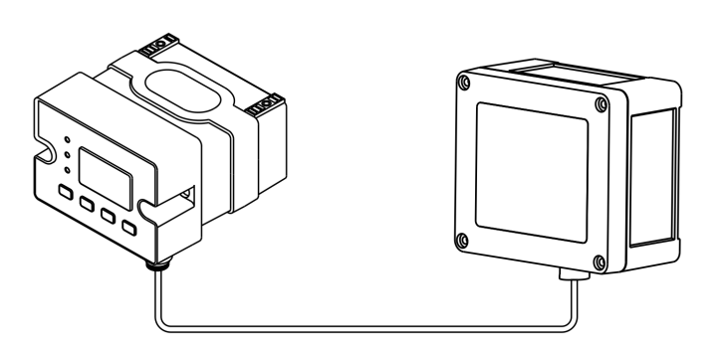
Wiring Diagram of Low Power Consumption Module Slave
Power supply & RS485 communication cable
Detector or sensor
Low power consumption module slave
Technical Specification

